Plane
# Source: AI Source: Provided by: [Data Path: Persons Table -> ID Column: 1, Name_En Column: Motasem Essam] -> From: [ChatGPT] on [7/25/2026]
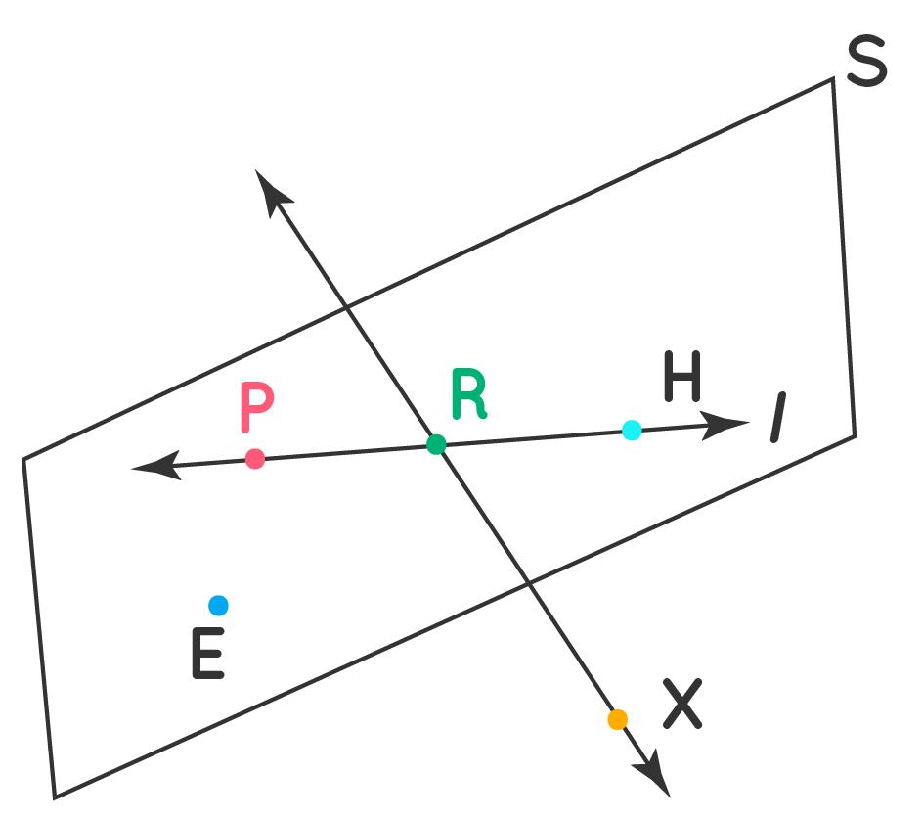
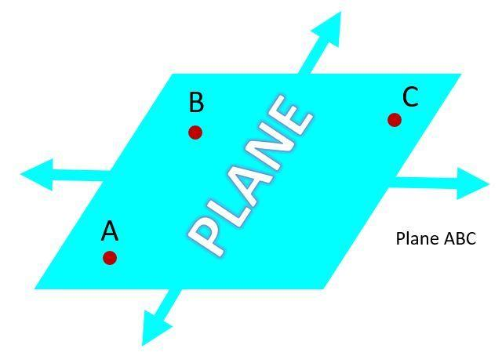
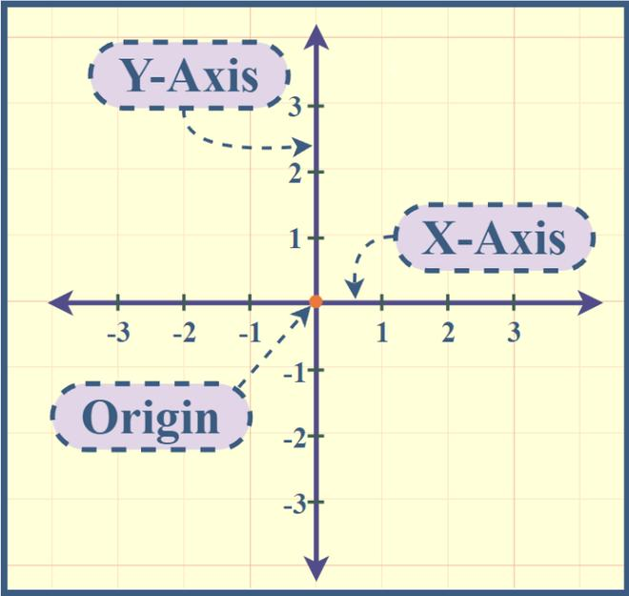
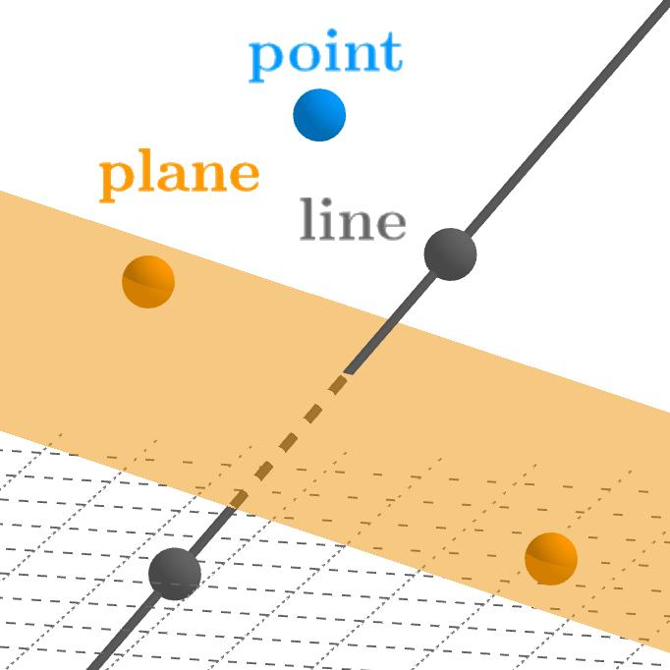
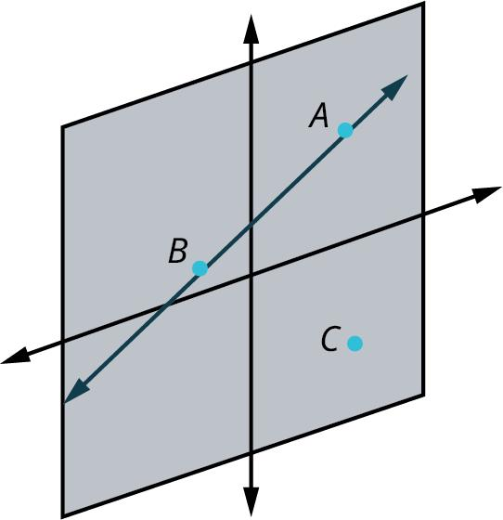
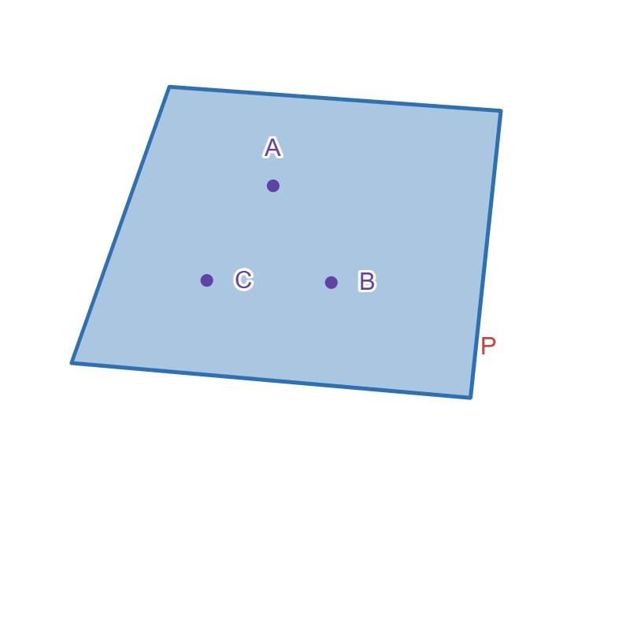

Definition
# Source: AI Source: Provided by: [Data Path: Persons Table -> ID Column: 1, Name_En Column: Motasem Essam] -> From: [ChatGPT] on [7/25/2026]
A Plane is a flat, two-dimensional surface that extends infinitely in all directions. It has length and width, but no thickness. A plane contains infinitely many points and lines and serves as the foundation for most concepts in plane geometry.
A plane cannot be physically drawn in its entirety because it extends without end.

Characteristics
# Source: AI Source: Provided by: [Data Path: Persons Table -> ID Column: 1, Name_En Column: Motasem Essam] -> From: [ChatGPT] on [7/25/2026]
A plane:
- Is flat.
- Has two dimensions (length and width).
- Has no thickness.
- Extends infinitely in all directions.
- Contains infinitely many points.
- Contains infinitely many lines.
- Can contain geometric figures such as triangles, circles, and polygons.

Illustration
# Source: AI Source: Provided by: [Data Path: Persons Table -> ID Column: 1, Name_En Column: Motasem Essam] -> From: [ChatGPT] on [7/25/2026]
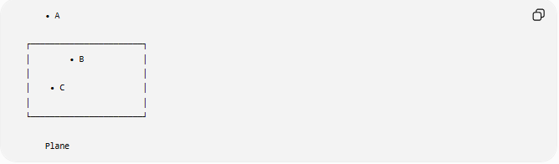
• A

┌───────────────────────┐
│ • B │
│ │
│ • C │
│ │
└───────────────────────┘

Plane
The edges represent only a portion of the plane for illustration. The actual plane extends infinitely.

Naming a Plane
# Source: AI Source: Provided by: [Data Path: Persons Table -> ID Column: 1, Name_En Column: Motasem Essam] -> From: [ChatGPT] on [7/25/2026]
A plane may be named by:
Three Non-Collinear Points
$$\text{Plane }ABC$$
where A, B, and C are three non-collinear points.

A Script Capital Letter
# Source: AI Source: Provided by: [Data Path: Persons Table -> ID Column: 1, Name_En Column: Motasem Essam] -> From: [ChatGPT] on [7/25/2026]
Plane 𝓟
A plane may simply be named Plane 𝓟.

Mathematical Representation
# Source: AI Source: Provided by: [Data Path: Persons Table -> ID Column: 1, Name_En Column: Motasem Essam] -> From: [ChatGPT] on [7/25/2026]
A plane in three-dimensional coordinate geometry is commonly represented by the equation:
$$Ax+By+Cz+D=0$$
where:
- $A$, $B$, $C$, and $D$are constants.
- $A$, $B$, and $C$are not all zero.

Examples
# Source: AI Source: Provided by: [Data Path: Persons Table -> ID Column: 1, Name_En Column: Motasem Essam] -> From: [ChatGPT] on [7/25/2026]
Examples of planes include:
- A sheet of paper (idealized).
- A tabletop.
- A wall.
- A classroom floor.
- A coordinate plane.
- A computer screen (idealized as flat).

Types of Planes
# Source: AI Source: Provided by: [Data Path: Persons Table -> ID Column: 1, Name_En Column: Motasem Essam] -> From: [ChatGPT] on [7/25/2026]
Common types include:
- Horizontal Plane
- Vertical Plane
- Oblique Plane
- Inclined Plane

Properties
# Source: AI Source: Provided by: [Data Path: Persons Table -> ID Column: 1, Name_En Column: Motasem Essam] -> From: [ChatGPT] on [7/25/2026]
A plane:
- Extends infinitely.
- Contains infinitely many points.
- Contains infinitely many lines.
- Is uniquely determined by three non-collinear points.
- Can intersect another plane in a line.

Applications
# Source: AI Source: Provided by: [Data Path: Persons Table -> ID Column: 1, Name_En Column: Motasem Essam] -> From: [ChatGPT] on [7/25/2026]
Planes are used in:
- Plane Geometry
- Solid Geometry
- Coordinate Geometry
- Engineering
- Architecture
- Construction
- CAD (Computer-Aided Design)
- Computer Graphics
- Robotics
- GIS (Geographic Information Systems)

Advantages
# Source: AI Source: Provided by: [Data Path: Persons Table -> ID Column: 1, Name_En Column: Motasem Essam] -> From: [ChatGPT] on [7/25/2026]
Studying planes helps to:
- Describe flat surfaces.
- Construct geometric figures.
- Analyze spatial relationships.
- Develop engineering drawings.
- Support three-dimensional modeling.

Limitations
# Source: AI Source: Provided by: [Data Path: Persons Table -> ID Column: 1, Name_En Column: Motasem Essam] -> From: [ChatGPT] on [7/25/2026]
A plane:
- Has no thickness.
- Cannot represent curved surfaces.
- Is an ideal mathematical object that cannot be completely drawn.

Comparison with Related Objects
# Source: AI Source: Provided by: [Data Path: Persons Table -> ID Column: 1, Name_En Column: Motasem Essam] -> From: [ChatGPT] on [7/25/2026]
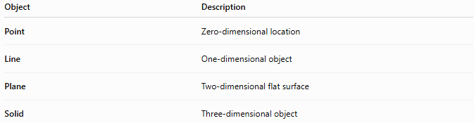
Object | Description
Point | Zero-dimensional location
Line | One-dimensional object
Plane | Two-dimensional flat surface
Solid | Three-dimensional object

Key Points
# Source: AI Source: Provided by: [Data Path: Persons Table -> ID Column: 1, Name_En Column: Motasem Essam] -> From: [ChatGPT] on [7/25/2026]
- A Plane is a flat two-dimensional surface.
- It extends infinitely in every direction.
- It has length and width, but no thickness.
- Three non-collinear points determine a unique plane.
- A plane can contain infinitely many points, lines, and geometric figures.
- Planes are fundamental in geometry, engineering, architecture, CAD, surveying, and computer graphics.

Conclusion
# Source: AI Source: Provided by: [Data Path: Persons Table -> ID Column: 1, Name_En Column: Motasem Essam] -> From: [ChatGPT] on [7/25/2026]
A Plane is a fundamental two-dimensional geometric object that extends infinitely in all directions and provides the surface on which most geometric figures are defined. It has length and width but no thickness, making it an ideal mathematical representation of a perfectly flat surface. Planes are essential in plane geometry, solid geometry, coordinate geometry, engineering, architecture, construction, CAD, robotics, GIS, surveying, and computer graphics, where they serve as the basis for modeling, design, and spatial analysis.

